How to use Http
The HTTP protocol support TCP Client Mode and support communication interface with RJ45 and WIFI and 4G.
Step 1: Open Net interface.
Open ReaderSoft file path
Double click ReaderSoft.exe logo.
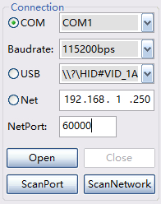, Choose connect port, such as COM, USB or Net(RJ45)
Then click Open button, it will show like this picture
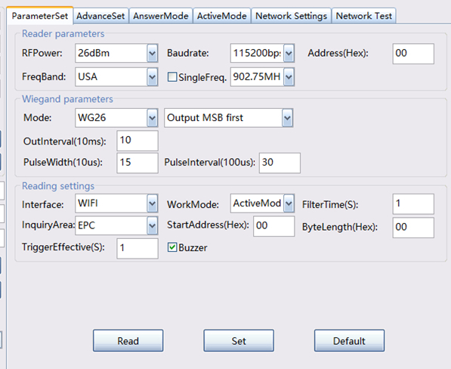
Pic 1
Select Interface is WIFI, or RJ45 or 4G, and select WorkMode is ActiveMode.
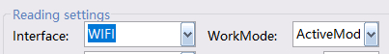
After set over, click Set button, if show paramters error, pls click read button first then set .

Step 2: Set Remote IP and port
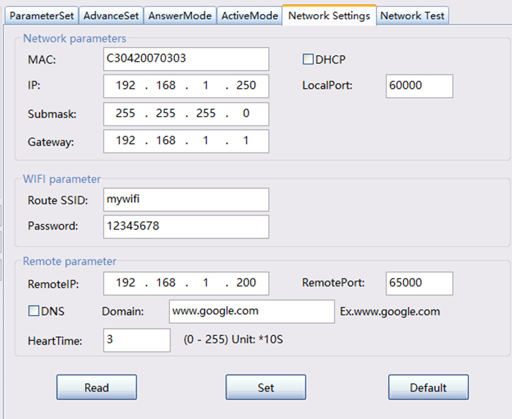
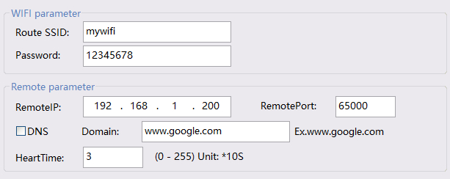
DNS mean open server domain mode, if open DNS, please input domain name such as www.google.com not with http:// , and RemoteIP is invalid. And it not support HTTPS encrypt web.
After set over, click Set button, if show paramters error, pls click read button first then set .
For reduce data package and speed up transmission, you can set filterTime, set up zero mean open filterTime.
ParamSet -> FilterTime
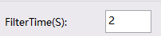
Step 3: Open HTTP protocol
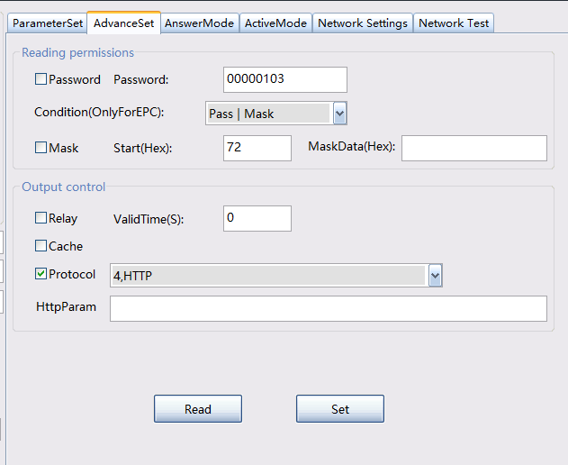
In the AdvanceSet
Select Protocol and select 4,HTTP
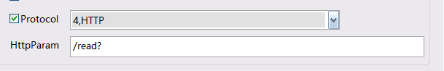
And input HttpParam, such as /read?
Click Set button and HTTP begin work.
Http procotol pls open HTTP protocol file to read.

